Economic in Public Policy

# Essay question: Critically apply the concept of ‘tax incidence’ to explain the findings reported in the following news article extract. What are the wider implications of the US-China trade war on the global political economy? ‘New York Fed and academic researchers found that U.S. consumers and companies have borne the brunt of the president’s trade war.’ (Source: Extract from the article ‘American Consumers, Not China, Are Paying for Trump’s Tariffs’, by Jeanna Smialek and Ana Swanson on 6 January 2020 at<https://www.nytimes.com/2020/01/06/business/economy/trade-war-tariffs.html>).

# 

# Word Count: 3998 (excluding reference list)

# 

Since March 2018, the economic battle between the United States and China has progressed from a tariff war to a technological conflict, and the trajectory of this war along with China-US ties will redefine the international order of the future (Yong, 2019). These kinds of economic confrontations can alter the entire global political economy. As a result, the purpose of this essay is to understand the impact of such wars. According to the New York Fed and academic experts, “U.S. consumers and companies have borne the brunt of the president's trade war”. With this information, the essay will investigate if the assertion is accurate and how the trade war affected the global political economy by applying the tax (tariff) incidence concept.

It is well known that powerful nations may use tariffs to alter trade conditions to their benefit. However, It is widely considered that this encourages retaliation and that the post-retaliation equilibrium leaves all countries worse off than they would be if trade were open (Kennan and Riezman, 1988). The timing of this trade war between the U.S.A and China could not be worse. It occurred as the effects of the monetary boost were starting to wear off, fuel prices were rising, political dangers were increasing, and the pandemic was approaching in 2020. (Johnson and Anton, 2017). All of this had an impact on the global economy, slowing growth. Global real GDP decreased by 0.1 percent in 2018, 0.8 percent in 2019, and 1.4 percent in 2020, according to a study. This economic slowdown minimizes any gains from trade diversions at the global level.

# Background

In 2018, former President Donald Trump began a trade war with the rest of the globe, which included various clashes with China and American allies (Canada, Mexico and so on). Each dispute has relied on a different legal argument from the United States, such as designating imports as a national security concern and then placing taxes and/or quotas on them (Bown and Kolb, 2018). According to several media reports and studies, these measures under the Trump administration have shifted the United States' foreign economic policy from liberalism, which had been pursued for decades, to protectionism (Boylan, McBeath, and Wang, 2020).

This war was particularly intense with China. The US initiated a Section 301 inquiry against China's trade practises in August 2017, and the US Trade Representative's Office accused China of unfair trade practises ranging from forced technology transfers to Chinese enterprises to intellectual property theft on March 22, 2018. Because of these considerations, the US imposed five rounds in July 2018, August 2018, September 2018, June 2019, and September 2019. of tariffs on Chinese exports, with China reacting to each round (Fajgelbaum, and Khandelwal, 2022).

Since the commencement of the trade war, the two nations have hiked tariffs on each other's exports significantly, from 2.6 percent to 17.5 percent on Chinese imports into the United States and from 6.2 percent to 16.4 percent on US imports into China (Bekkers, and Schroeter, 2020). Tariffs on Chinese imports entering the United States were cut to 16% under the Phase 1 Agreement signed in January 2020. Tariffs on Chinese imports have been justified for a number of reasons, including the following: to repair bilateral trade imbalances, such as the USA's deficit; (ii) to make tariffs more reciprocal (as defined by Griswold (2019) in the United States context demands that tariff rates imposed by the US at the tariff line level be at the same level as tariffs suffered by the US); (iii) reinstate manufacturing employment; (iv) Address Chinese policies that have harmful consequences, such as insufficient intellectual property protection and subsidies to state-owned enterprises (heavy involvement of Chinese government in the economy), and forced technology transfer (ibid).

The graph below depicts the US economy's deficit (the negative trade balance) with China and its increase in 2018, which was one of the primary grounds for the Trump administration to impose harsh tariffs on China

Figure (1)

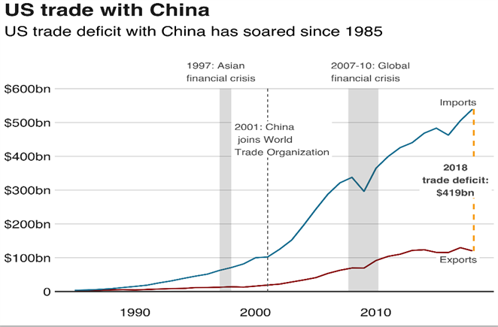

Source: (Palumbo and da Costa, 2022)

Figure (2)

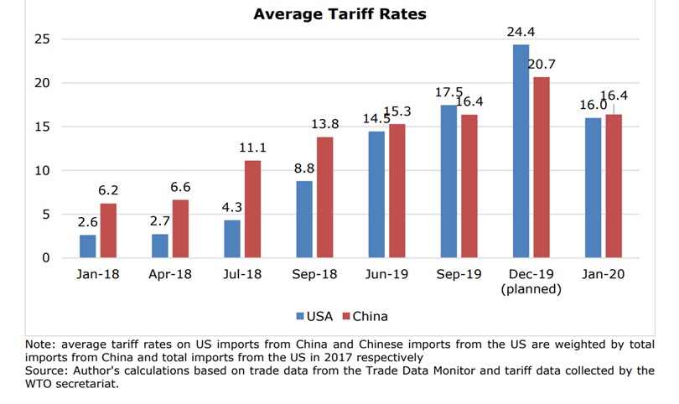

Source: (Bekkers, and Schroeter, 2020)

The graph above showcases the tariffs applied by both nations from 2018 till the phase one agreement was inked. Thus, now the question now boils down to which country bore the consequences and why.

# Tariffs, consumer surplus, and producer surplus.

Tariffs are taxes imposed on goods imported from other countries (Kane, 2022). Its goal is to safeguard domestic manufacturers from international rivals. In most cases, the duty is paid by the importer. Exporters often do not 'pay' the tariff as such; rather, they suffer negative consequences because their goods become more expensive on the overseas market. For example, in 2018, the United States imposed duties on washing machine imports, with taxes ranging from 20% to 50% (Pettinger, 2019). The tariff's influence on washing machine imports resulted in:

* Significantly increased consumer prices (approx. 12 percent)
* Increased profits for indigenous US washing machine manufacturers
* Tariff income increases for the US government

The diagram below shows the effect of tariffs on Chinese imports (ibid)

Figure (3)

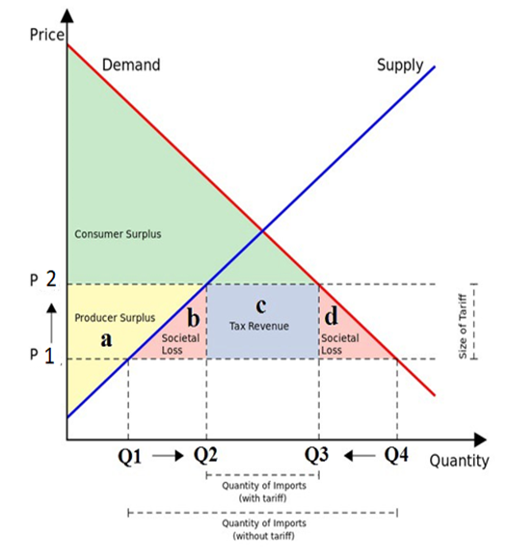

Source: (Perry, 2016)

P1= price before tariff

Q4= quantity demanded: Q1 amount of demand is met through domestic production and the remaining is met through imports which are Q4-Q1

P2= price after tariff

Q3- demand for machines falls due to a rise in prices (Law of demand). An increase in tariff led to increased domestic production i.e., from Q1 to Q2 but the imports reduced from Q4- Q1 to Q3-Q1 because of a fall in overall demand.

The figure implies the following:

**Costs of Tariffs:** The region - (a + b + c + d) makes American consumers worse off. As before the tariff, the consumer surplus was the green shaded area plus the a+b+c+d area. Consumer surplus is an economic measure of the benefits that consumers obtain. It occurs when the price customers pay for a product or service is less than the price, they are willing to pay (Henderson, 1941).

**Tariff Advantages:** Area a benefits US producers, whereas Area c benefits the government in the form of revenue. The rise in prices has resulted in an increase in the producer surplus. [The market value price that a vendor would earn for their things is more than the minimum price that they would accept for them (Pigou, 1910). In the picture above, the producer is willing to sell some quantity of goods for a price less than P2, but the tariff and demand allow it to sell the items at a higher price than he accepts, thereby benefitting the producer].

**Tariff Net Economic Loss:** The tariff expenses - (a + b + c + d) to US consumers are larger than the tariff benefits to producers and the government (a + c), resulting in a net economic or welfare loss of areas -(b) + -(d), — those are the tariff costs that are not compensated by any benefits. This is referred to as deadweight loss in economics (Perry, 2016). Deadweight loss is a significant notion in economics that we will encounter any time a policy or activity decreases the volume of transactions below the ideal market equilibrium quantity (from total quantity Q4 to Q3) and results in inefficient resource usage. It is critical to recognize that deadweight loss is a societal loss—it is a drop in overall surplus, a surplus loss that benefits no one. It is not the same as a surplus loss to one person that later accrues as a benefit to another, which an economist would refer to as a surplus transfer from one person to another (Krugman and Wells, 2018, pp.294–297).

Thus, any imposition of tariff by any country is bound to reduce overall welfare and lead to market inefficiency.

# Who is paying for the Trade war?

Understanding two basic components are crucial in analyzing the claims of US consumers who have to bear the burden: how did China react—did it lower its export pricing—and who paid the final tax in the US. This may be assessed using the tax incidence concept. That is, the surpluses of consumers and producers are compared after and before taxes as done above. If the excess consumer surplus is minimized. The consumer was responsible for paying the tax and vice versa.

This article analysis the reasons why the US consumers are under more strain than China in the following points:

1. **The complete pass-through of tariff**: The reaction of import prices to tariffs is significant because this price response includes information on the incidence of trade policy. If the tariff's impact is mostly on the exporter, the ex-tariff import price will decline dramatically, leaving the importer (who pays the ex-tariff price plus the duty) largely unaffected (Cavallo et al., 2019). In this instance, the importing government's tariff revenues are mostly derived from the foreign exporter's lower profit margins. This is termed an incomplete pass-through of tariffs.  
   Alternatively, if the tariff's incidence is predominantly on the importer, the ex-tariff import price will be relatively steady, raising the total cost the importer must pay (including tariffs) to acquire foreign products (ibid). This is termed a complete pass-through of tariffs.   
   The data and the findings derived using Census unit values in Amiti, Redding, and Weinstein (2019) and Fajgelbaum, Goldberg, Kennedy, and Khandelwal (2019) show that the increase in the price of the goods affected by the import tariff was insignificant and similarly the Chinese economy didn’t significantly decrease the price of the good under tariff attack and the trends show that the price remained mostly stable for the period between 2018-19. This reflects that most of the brunt of the tariffs was borne by the USA firms (importers) in the form of reduced profit margin.  
     
   Figure (4)  
   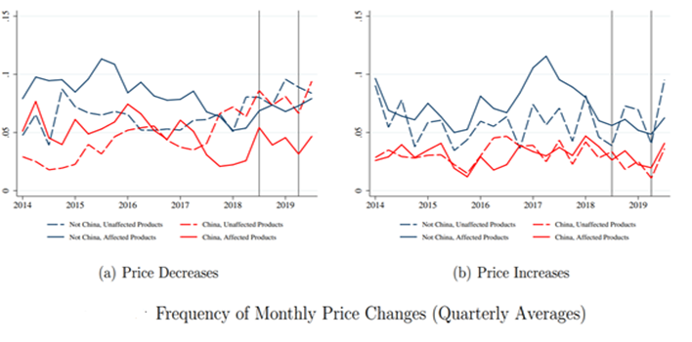  
   Source: (Cavallo et al., 2019)  
     
   The above figure has been taken from the working paper titled “Tariff Passthrough at the Border and at the Store: Evidence from US Trade Policy”. The graphs reflect the change in prices both increase and decrease. It does so separately for four types of goods: those unaffected by tariffs and imported from countries other than China, those unaffected even though imported from China, those affected but imported from outside of China, and those affected and imported from China, with the latter group including only goods for which the importer must pay a tariff (Cavallo et al., 2019). There are no discernible variations between the four categories, and the pricing of products in the last category appears to be the most constant. The right-hand figure shows the analogous figures for price rises and, once again, finds no indication of significant changes in pricing behaviour because of tariffs (ibid). These graphs demonstrate that the incidence of the tariffs fell mostly on US importers.  
     
   However, this finding does not mean that China gains from the tax. Even if Chinese exporters received the same price and profit margin per unit sold in the US, tariffs would lower the number of units sold (Fajgelbaum, and Khandelwal, 2022).
2. **The demand elasticity of the goods**: what informs the pass-through of tariff is the demand and supply elasticity of the product. It is worth mentioning that the complete pass-through of tariff occurs because of inelastic demand or elastic supply (ibid). Elasticity is a concept that describes the change in quantity demanded or supplied because of a change in price. Little change is called inelastic, and substantial change is elastic. The supply of the Chinese products (exports) happens to be elastic as the Chinese economy could easily reallocate its supply to some other country thus not obliging itself to reduce the price of its product to absorb the tariff shock. Also, the demand for Chinese exports in the USA is inelastic that leading to an insignificant decrease in the demand.  
   The data, on the other hand, imply that US exporters have dramatically decreased their prices in reaction to foreign levies. The fact that we are seeing drops in post-tariff export prices of selected US items implies that the retaliatory tariffs imposed on the US have a significant impact on the US as well (Cavallo et al., 2019). Now the point is, why did US exporters lower their prices so much more when confronted with international duties than foreign exporters did when confronted with US tariffs? Differences in the categories of commodities impacted by trade policy are crucial. Because of the accessibility and availability of substitutes, most of the US-affected exports were difficult to shift to other nations (most US exports consist of commodities for which substitutes are readily available, the US economy was forced to decrease its prices to absorb the shock and stay competitive in the international market.). For example, the goods China imposed taxes on were fruits, dry fruits, meat, and so on (Rosenfeld and Chandran, 2018). Whereas the Chinese imports in the US were hard to replace. This might explain why US imports had little or no ex-tariff price drops while US exports experienced moderate ex-tariff price declines (ibid).
3. **Intermediate goods**: Another reason the incidence was higher in the US economy was that more than 60% of the items affected by the 2018 US tariffs were processed intermediate goods. Processed intermediate goods are more technologically complex than other types of products, have lower substitution elasticity, and are exchanged more persistently between enterprises. As a result, such commodities are more likely to have greater switching costs, which might slow down the process of replacing imports and explain why there has been so little trade diversion thus far (Cigna et al., 2020). Furthermore, due to China's large market dominance in the manufacture of many US imports, it became difficult for US enterprises to simply identify substitutes and importers bared the tariffs (Mutambara, 2019).
4. After ascertaining the behaviour of US import prices, we may now examine how tariffs influenced prices farther downwards in the US economy:

**Retailers**: Data shows that tariffs have resulted in increased retail prices, but the impacts have been modest – at least so far – since merchants have absorbed much of the higher costs connected with tariffs by earning lower margins on their sales. Most retailers conducted some tariff front-running, which means they built up stocks before the highest duties took effect and began diverting at least some of their purchases to non-Chinese suppliers (Cavallo et al., 2019). This prevented them from transferring the tariff burden to ultimate customers and harming sales. As a result, the drop in production surplus was greater than the fall in consumer surplus. This, however, did not happen with every tariffed good.

* 1. **Consumers**: According to research by Trade Partnership Worldwide (2019), threatened US tariffs on Chinese imports have harmed American consumers. They found that the steel and aluminum tariffs and quotas, as well as 25% tariffs on US imports of certain Chinese goods plus retaliation by November 2018, cost an average American household of four $767 a year. When they added 25% tariffs on all remaining Chinese imports, plus retaliation, the yearly impact on an average American household of four increased to $2,294 (Mutambara, 2019). For each year that the tariffs were in force, these sums were extra money that the household had to pay out of pocket to cover higher expenses for products and services (ibid).  
     For instance, washing machines, the first consumer commodity to be subjected to tariffs in 2018, provide an excellent case study of the impact and cost to customers (BRINK Editorial Staff, 2019). An economist from the Federal Reserve Board of Governors and two economists from the University of Chicago discovered that eight months after the first wave of tariffs were imposed, the median price of washing machines increased by $86—an approximately 12% markup. They also revealed something fascinating about a complementary commodity that had no tariffs placed on it. The price of dryers, which had not been targeted by any trading strategy, increased by the same amount: $92 per unit, a 12% increase (ibid). A working paper by the National Bureau of Economic Research concludes that the previous tariff on the washing machine was avoided redirecting the trade with other countries but the 2018 tariff stymied the competition enabling producers in the United States to freely hike their prices.

The below graph presents the rise in prices of appliances due to tariffs. Also, figure (3) presents how the increase in the prices would have led to increased tax incidence on the consumer and more profit for the producers.  
  
Figure (5)  
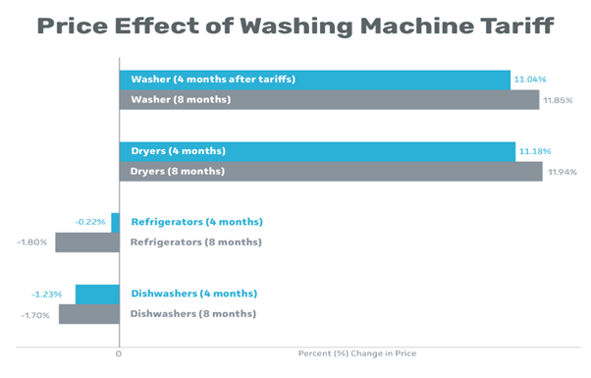  
Source: (calculations by Hortacsu, Tintelnot, and Flaaen, 2019)

# The Impact on the Global Economy

Since this trade war involved the world's two largest economies, it had an impact on the global economy. The International Monetary Fund warned that the trade war between the United States and China will lower the global economy in 2019 to its worst rate since the 2008-2009 financial crisis (Reuters, 2019) In 2022, the worldwide average fall in real GDP and export value is forecast to be 1.96 percent and 16.95 percent, respectively, relative to the baseline (Bekkers et al., 2019). The trade war had an influence in the following areas at the global level:

**(i) Global supply disruptions:** Tariffs raise the cost of imported products, reducing demand for them. When tariffs are imposed exclusively on certain countries, such as in the US-China trade war, trade diversion occurs because importers can avoid paying tariffs by sourcing goods from other countries.

In this context, a crucial question is whether the nation has been more successful in replacing China in the US market. The trade diversion effects of US tariffs on China helped Taiwan Province the most, accounting for nearly US$4.2 billion in additional shipments to the US in the first half of 2019. The gains for China's Taiwan Province are largely due to an increase in exports of office machinery and communication equipment. Mexico's increased exports to the United States are anticipated to be worth over US$ 3.5 billion, with the agri-food, transportation equipment, and electrical machinery sectors accounting for the majority of the increase (Nicita, 2019). Trade diversion effects totalling roughly US$ 2.7 billion benefitted the European Union, thanks mostly to increased exports in the equipment industry. The benefits to Vietnam are estimated to be worth roughly $2.6 billion and are focused on communication equipment and furnishings (Nicita, 2019). The benefits of trade diversion to the Republic of Korea, Canada, and India were less substantial, but nevertheless considerable (ranging from US$ 0.9 to 1.5 billion). The rest of Latin America, Sub-Saharan Africa, and the rest of the world reaped very little benefits from trade diversion (ibid).

The below graph presents the plunge in China’s export to the US while an increase from other countries. However, this happened only with a few goods which could be replaced.

Figure (6)

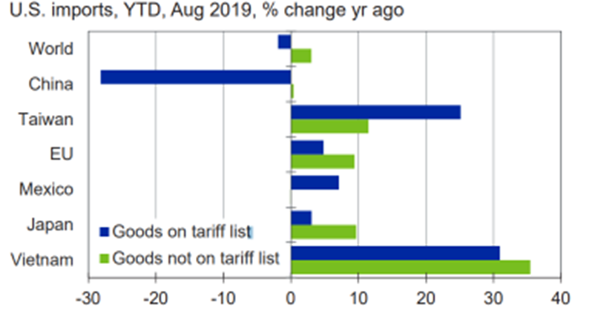

Source: (Mukherjee, 2020)

**(ii) Effect on the overall GDP:** However, trade diversion effects may not always occur and are frequently insufficient, implying that other nations can acquire just a fraction of the trade, with the remainder lost or absorbed by the country imposing the tax. Inferring that trade wars typically result in lost market efficiency and foregone productivity. Thus, this is reflected in the prediction of low GDP across countries.

According to a model-based assessment by the Bank of Finland, a tariff war reduces global GDP growth by about 0.7 percentage points (Ikonen, Kerola, and Vilmi, 2019).

A World Trade Organization working paper anticipated that the trade war will continue to have long-term consequences on GDP, with an estimate of the effect in 2022. The percentage reduction is seen in the two figures below. The global average real income is expected to shrink by 1.96 percent. The 2nd graph illustrates the fall in GDP when compared with Baseline GDP.

Figure (7)

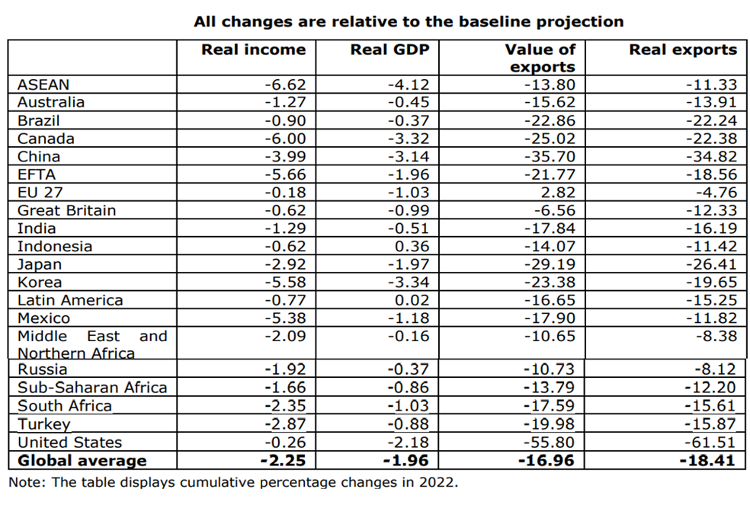

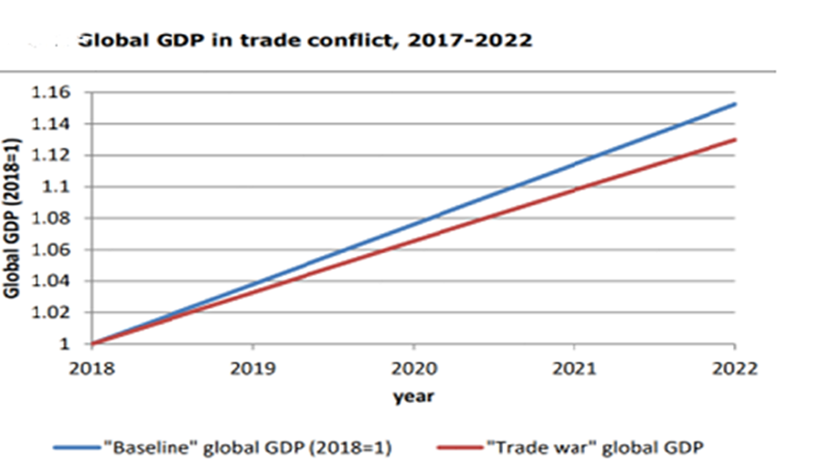

source: (Bekkers et al., 2019)

**(iii) Employment effects:** the global supply chain disruptions led to the reallocation of workers and job loss across sectors. In the US alone the imposition of tariffs on intermediate goods increased the production cost which was offset by reducing the number of employees. According to reports, 245,000 US jobs were lost, and further, there would be 732,000 fewer US jobs in 2022 and 320,000 fewer jobs by 2025 (Reuters Staff, 2021). At the world level according to the WTO estimation, the percentage of employees leaving their initial sector of employment due to the global trade war is 1.15 percent for high-skilled workers and 1.74 per cent for low-skilled workers and from 0.65 percent and 0.76 percent in Brazil and Canada, respectively, to 4.46 percent and 4.92 percent in EFTA nations and Canada (Bekkers et al., 2019). This highlights the inefficient and underutilisation of human resources. The movement of workers across the world would have been to the sectors where the production and the wage were less affected by the war.

**(iv) International political relations:** the imposition of tariffs on goods like steel, aluminium, cars, and so on by the US administration led imposing retaliatory tariffs on the US not just by China but several other countries thus harming the bilateral and multilateral relations. The graphic below depicts how the United States' tariffs impacted its trade partners, triggering retaliation.

Figure (8)

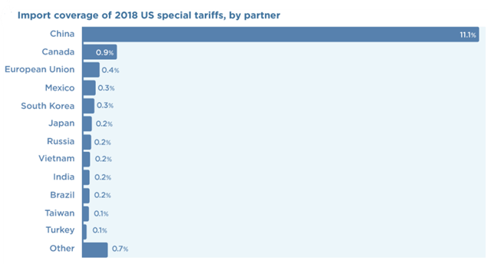

Source: (Bown, and Zhang, 2019)

For instance, the EU has responded to the imposition of tariffs on EU steel and aluminium exports by filing a WTO dispute settlement case and applied "rebalancing" tariffs under Article XVIII of the WTO's General Agreement on Tariffs and Trade (Chase, Sparding and Mukai, 2018). Canada placed a C$16.6 billion duty on US imports of steel, aluminium, and other materials. Retail and food items were subject to a 10% import levy. The Canadian government stated that the tariffs will remain in force until either (a) the United States withdraws its duties on Canadian steel or aluminium, or (b) the amount of taxes collected by Canada equals the incidence of the United States' tariffs on steel and aluminium (Littler, 2018). These instances give evidence of the escalating trade tensions and the global environment of protectionism.

**(v) Stock Market:** The Trade wars between powerful nations like the United States and China do not go unnoticed by people across the world. "In this case, a number of moves have left most markets a bit worse for wear, but the most severe harm has been avoided," says Mark Cherry, a business writer at Australia2Write and NextCoursework (Delgado, 2020). The consequences include a 0.7 percent drop in US stock futures and a drop in Asian markets (ibid). The Asian markets were affected more because of having a more important link to the US-China value chains as stated by Amstad et al. (2022). Also, oil prices fell substantially, as would have been predicted following the Chinese levies placed on US petroleum (Delgado, 2020).

# Conclusion

According to trade theory, free trade is essential in an era of interdependence since protectionist policies lead to market inefficiencies. It diverts the country's resources towards the manufacturing of a good that might be purchased at much lower costs from other nations, raising the overall cost and prices in the economy. For example, as described in the article, the US-China trade war caused societal loss and increased final-goods prices.

Further, this essay discusses the tax incidence of the US-China trade war and concludes that US Consumers and importers were affected more than their Chinese counterparts. Overall, this war impacted the global political economy negatively and many simulations conclude that the economy will continue to experience the negative impact in the long term as the trade war also coincided with the pandemic which hurt the economy further. Nevertheless, the uncertainty associated with trade makes quantifying the specific impact on the economy difficult.

In conclusion, countries while framing their trade policies should be conscious of their impact on the global economy both in the long run and short run. It is required by both the US and Chinese economies to go back to pre-2018 status gradually and obey the trade regulations set up by international agreements. Countries should always remember the many benefits of global trade and how it contributes to the welfare and prosperity of billions of people throughout the world (Irwin, 2020).

# 

# REFERENCES

1. Amstad, M., Gambacorta, L., He, C. and Xia, F.D. (2022). Trade Sentiment and the Stock Market: New Evidence Based on Big Data Textual Analysis of Chinese Media. SSRN Electronic Journal. doi:10.2139/ssrn.4070379.
2. Bekkers, E. and Schroeter, S., 2020. An economic analysis of the US-China trade conflict (No. ERSD-2020-04). WTO Staff Working Paper.
3. Bekkers, E. and Schroeter, S., 2020. An economic analysis of the US-China trade conflict (No. ERSD-2020-04). WTO Staff Working Paper.
4. Bekkers, E., Teh, R., Fontagne, L., Fouré, J., Hoekman, B., Koopman, R., Nelson, D., Nicita, A. and Olarreaga, M. (2019). POTENTIAL ECONOMIC EFFECTS OF A GLOBAL TRADE CONFLICT Projecting the medium-run effects with the WTO Global Trade Model We want to thank. [online] Available at: <https://www.wto.org/english/res_e/reser_e/ersd201904_e.pdf>.
5. Bown, C. and Kolb, M. (2018). Trump’s Trade War Timeline: An Up-to-Date Guide. [online] PIIE. Available at: https://www.piie.com/blogs/trade-investment-policy-watch/trump-trade-war-china-date-guide [Accessed 4 May 2022].
6. Bown, C.P. and Zhang, E. (Yiwen) (2019). Measuring Trump’s 2018 Trade Protection: Five Takeaways. [online] PIIE. Available at: <https://www.piie.com/blogs/trade-and-investment-policy-watch/measuring-trumps-2018-trade-protection-five-takeaways>.
7. Boylan, B.M., McBeath, J. and Wang, B., 2021. US–China relations: Nationalism, the trade war, and COVID-19. Fudan Journal of the Humanities and Social Sciences, 14(1), pp.23-40.
8. BRINK Editorial Staff (2019). The Current Trade War Is Costing Consumers. Washing Machines Can Help Explain Why. [online] BRINK – Conversations and Insights on Global Business. Available at:<https://www.brinknews.com/the-current-trade-war-is-costing-consumers-washing-machines-can-help-explain-why/>.
9. Cavallo, A., Gopinath, G., Neiman, B. and Tang, G. (2019). Tariff Passthrough at the Border and at the Store: Evidence from US Trade Policy. SSRN Electronic Journal. doi:10.2139/ssrn.3470793.
10. Chase, P., Sparding, P. and Mukai, Y. (2018). Consequences of US trade policy on EU-US trade relations and the global trading system Policy Department for External Relations. [online] Available at:<https://www.europarl.europa.eu/RegData/etudes/STUD/2018/603882/EXPO_STU(2018)603882_EN.pdf>.
11. Cigna, S., Meinen, P., Schulte, P. and Steinhoff, N. (2020). Working Paper Series The impact of US tariffs against China on US imports: evidence for trade diversion? [online] Available at:<https://www.ecb.europa.eu/pub/pdf/scpwps/ecb.wp2503~ca71d98a53.en.pdf>.
12. Delgado, M. (2020). Global Stock Markets Impacted by Trade War. [online] Global Trade Magazine. Available at: https://www.globaltrademag.com/global-stock-markets-impacted-by-trade-war/ [Accessed 12 May 2022].
13. Fajgelbaum, P.D. and Khandelwal, A.K., 2022. The Economic Impacts of the US–China Trade War.
14. Henderson, A. (1941). Consumer’s Surplus and the Compensating Variation. The Review of Economic Studies, 8(2), p.117. doi:10.2307/2967468.
15. Hergt, B. (2020). The effects of tariff rates on the U.S. economy: what the Producer Price Index tells us. [online] 9(13). Available at: <https://www.bls.gov/opub/btn/volume-9/pdf/the-effects-of-tarifff-rates-on-the-u-s-economy-what-the-producer-price-index-tells-us.pdf>.
16. Hortacsu, A., Tintelnot, F. and Flaaen, A. (2019). The Production, Relocation, and Price Effects of US Trade Policy: The Case of Washing Machines. SSRN Electronic Journal. [online] doi:10.2139/ssrn.3374918.
17. Ikonen, P., Kerola, E. and Vilmi, L. (2019). The trade war has significantly weakened the global economy. [online] Bank of Finland Bulletin. Available at:<https://www.bofbulletin.fi/en/2019/4/the-trade-war-has-significantly-weakened-the-global-economy/#:~:text=According%20to%20a%20model%2Dbased>.
18. Irwin, D.A. (2020). FREE TRADE UNDER FIRE: fifth edition. S.L.: Princeton University Press, pp.320–322.
19. Johnson, S. and Anton, J. (2017). To make better decisions, you need to see the big picture. [online] IHS Markit. Available at:<https://ihsmarkit.com/solutions/us-china-trade-war-impacts.html>.
20. Kane, J., 2022. StackPath. [online] Instituteforgovernment.org.uk. Available at: <https://www.instituteforgovernment.org.uk/explainers/trade-tariffs> [Accessed 7 May 2022].
21. Kennan, J. and Riezman, R. (1988). Do Big Countries Win Tariff Wars? International Economic Review, 29(1), p.81. doi:10.2307/2526808.
22. Krugman, P.R. and Wells, R. (2018). Economics. New York, Ny: Worth Publishers, A Macmillan Education Imprint, pp.294–297.
23. Littler, K. (2018). Canada Imposes Retaliatory Tariffs on Specific U.S. Goods and Groceries – Understanding the Impact on Retailers in Canada. [online] Retail Council of Canada. Available at: https://www.retailcouncil.org/tariffs/canada-imposes-retaliatory-tariffs-on-specific-u-s-goods-and-groceries-understanding-the-impact-on-retailers-in-canada-2/ [Accessed 12 May 2022].
24. Mukherjee, S. (2020). Trade Diversion Since the U.S.-China Trade War. [online] Available at: <https://www.moodysanalytics.com/-/media/article/2020/Trade-Diversion.pdf>.
25. Mutambara, T.E. (2019). Implications of the US–China Tit-for-Tat Tariff Escalation: A Literature Review of Standard Trade Theory and Empirical Evidence on Economic Consequences and Effects on Both Countries. Management and Economics Research Journal, 5, p.1. doi:10.18639/merj.2019.952971.
26. Nicita, A. (2019). Trade and trade diversion effects of United States tariffs on China. [online] Available at: <https://unctad.org/system/files/official-document/ser-rp-2019d9_en.pdf>.
27. Palumbo, D. and da Costa, A., 2022. Trade war: US-China trade battle in charts. [online] BBC News. Available at: <https://www.bbc.co.uk/news/business-48196495> [Accessed 7 May 2022].
28. Perry, M.J. (2016). An economic analysis of protectionism clearly shows that Trump’s tariffs would make us poorer, not…. [online] Medium. Available at: <https://medium.com/@MarkJPerry/an-economic-analysis-of-protectionism-clearly-shows-that-trumps-tariffs-would-make-us-poorer-not-ee83d55a12d9>.
29. Pigou, A.C. (1910). Producers’ and Consumers’ Surplus. The Economic Journal, 20(79), p.358. doi:10.2307/2221029.
30. Reuters (2019). IMF says trade war will cut global growth to lowest since financial crisis a decade ago. [online] CNBC. Available at:<https://www.cnbc.com/2019/10/15/imf-says-trade-war-will-cut-global-growth-to-lowest-since-financial-crisis-a-decade-ago.html>.
31. Reuters Staff (2021). U.S.-China trade war has cost up to 245,000 U.S. jobs: business group study. Reuters. [online] 14 Jan. Available at: <https://www.reuters.com/article/us-usa-trade-china-jobs-idUSKBN29J2O9>.
32. Rosenfeld, E. and Chandran, N. (2018). China announces it’s imposing new tariffs on 128 US products. [online] CNBC. Available at: https://www.cnbc.com/2018/04/01/china-announces-new-tariffs-on-us-meat-and-fruit-amid-trade-war-fears.html.
33. Smialek, J. and Swanson, A. (2020). American Consumers, Not China, Are Paying for Trump’s Tariffs. The New York Times. [online] 6 Jan. Available at: <https://www.nytimes.com/2020/01/06/business/economy/trade-war-tariffs.html>.
34. Tejvan Pettinger (2019). Effect of US tariffs on Chinese imports - Economics Help. [online] Economicshelp.org. Available at: <https://www.economicshelp.org/blog/147165/economics/effect-of-us-tariffs-on-chinese-imports/>.
35. Yong, W. (2019) “Interpreting Us-China Trade War Background, Negotiations and Consequences,” China International Strategy Review, 1(1), pp. 111–125. doi: 10.1007/s42533-019-00019-6